**Praktikum Pemrograman Berbasis Web**

**Program Laravel**

**Disusun Untuk Memenuhi Tugas Pertemuan Ke - 09**



**Dosen**

**Adi Wahyu Pribadi, S.Si., M.Kom**

**Disusun Oleh**

**Dio Prasetyo (4522210148)**

**Fakultas Teknik**

**Program Studi Teknik Informatika**

**Universitas Pancasila**

**Jakarta**

**Tahun Akademik 2024 / 2025**

**I. Screen Shoot Tampilan Belajar Laravel Video 01**

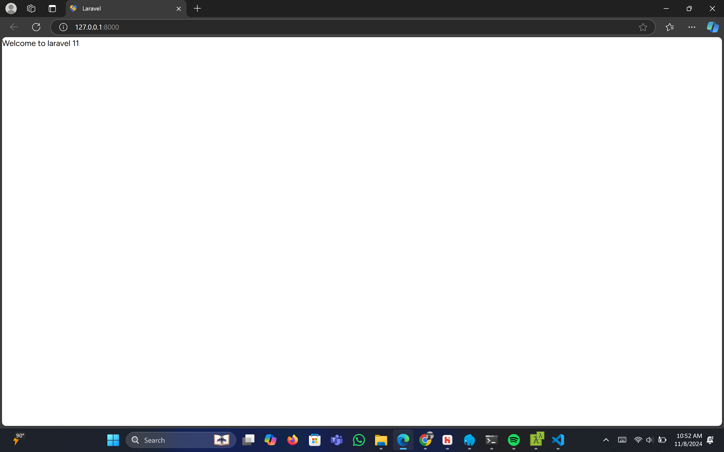

**II. Screen Shoot Tampilan Belajar Laravel Video 02**

* **Tampilan Section Home**

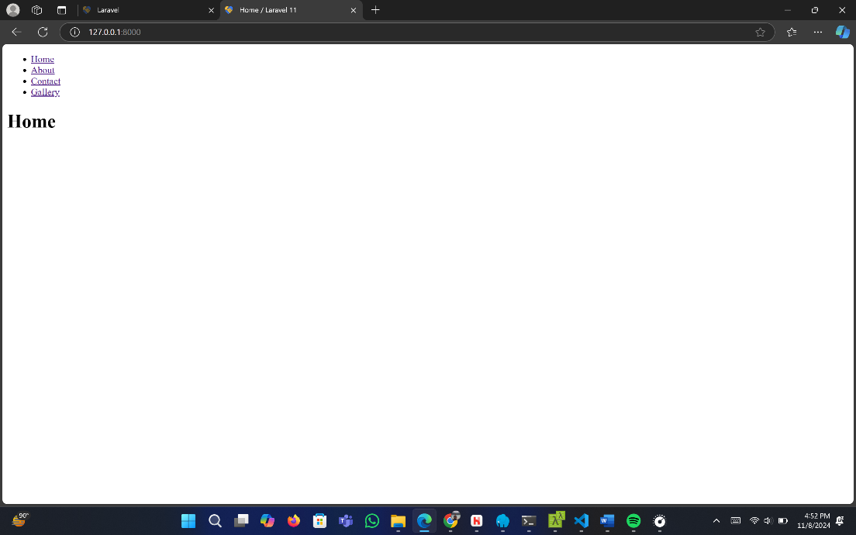

* **Tampilan Section About**

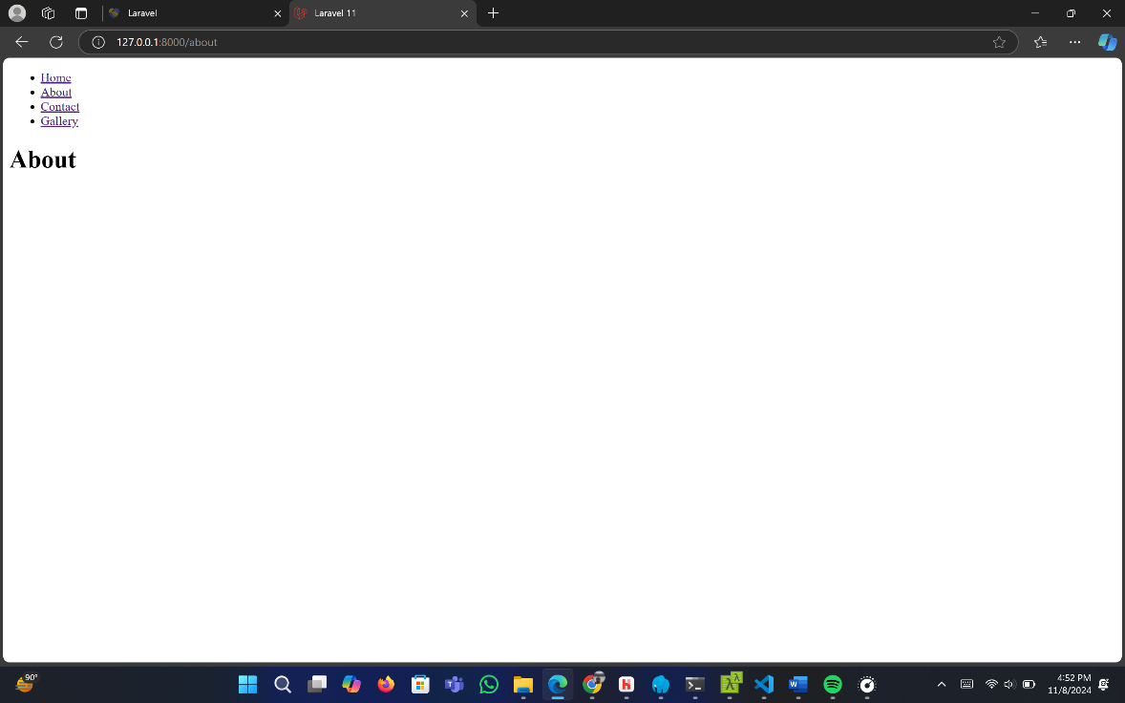

* **Tampilan Section Contact**

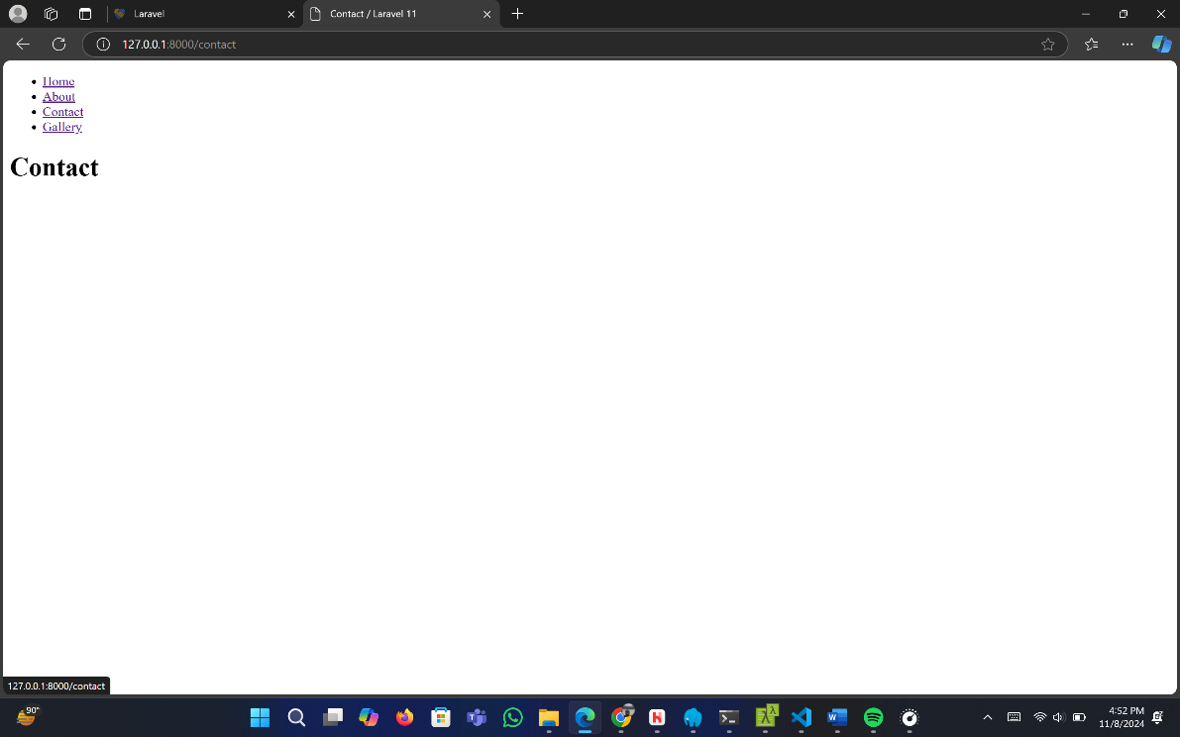

* **Tampilan Section Gallery**

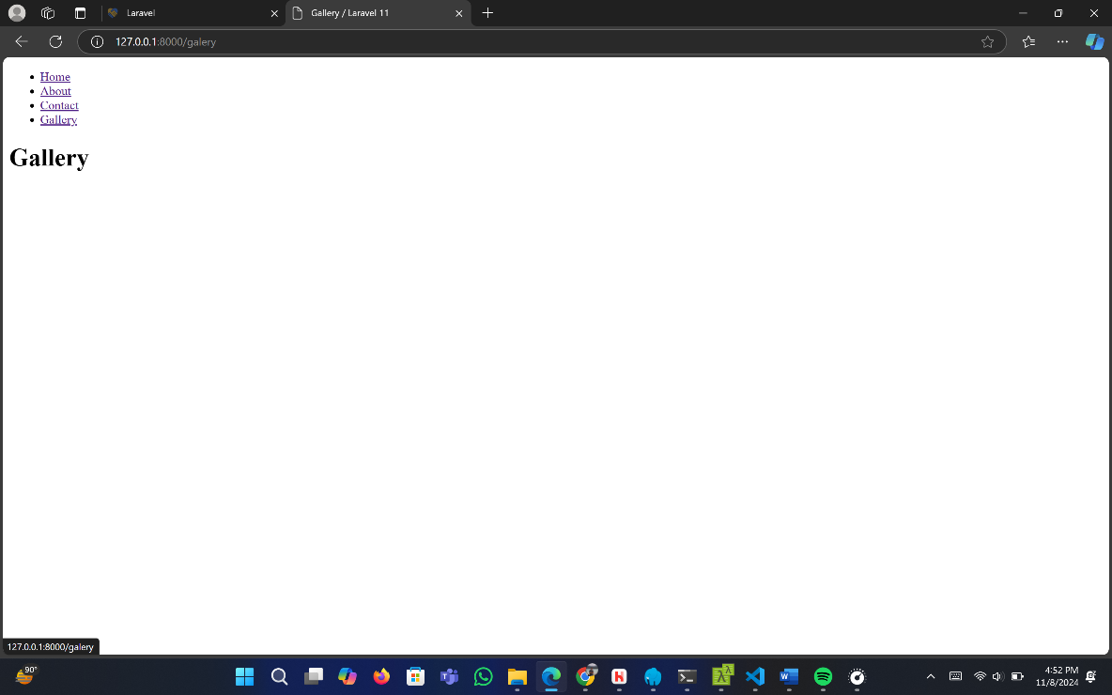

**III. Screen Shoot Tampilan Video 03**

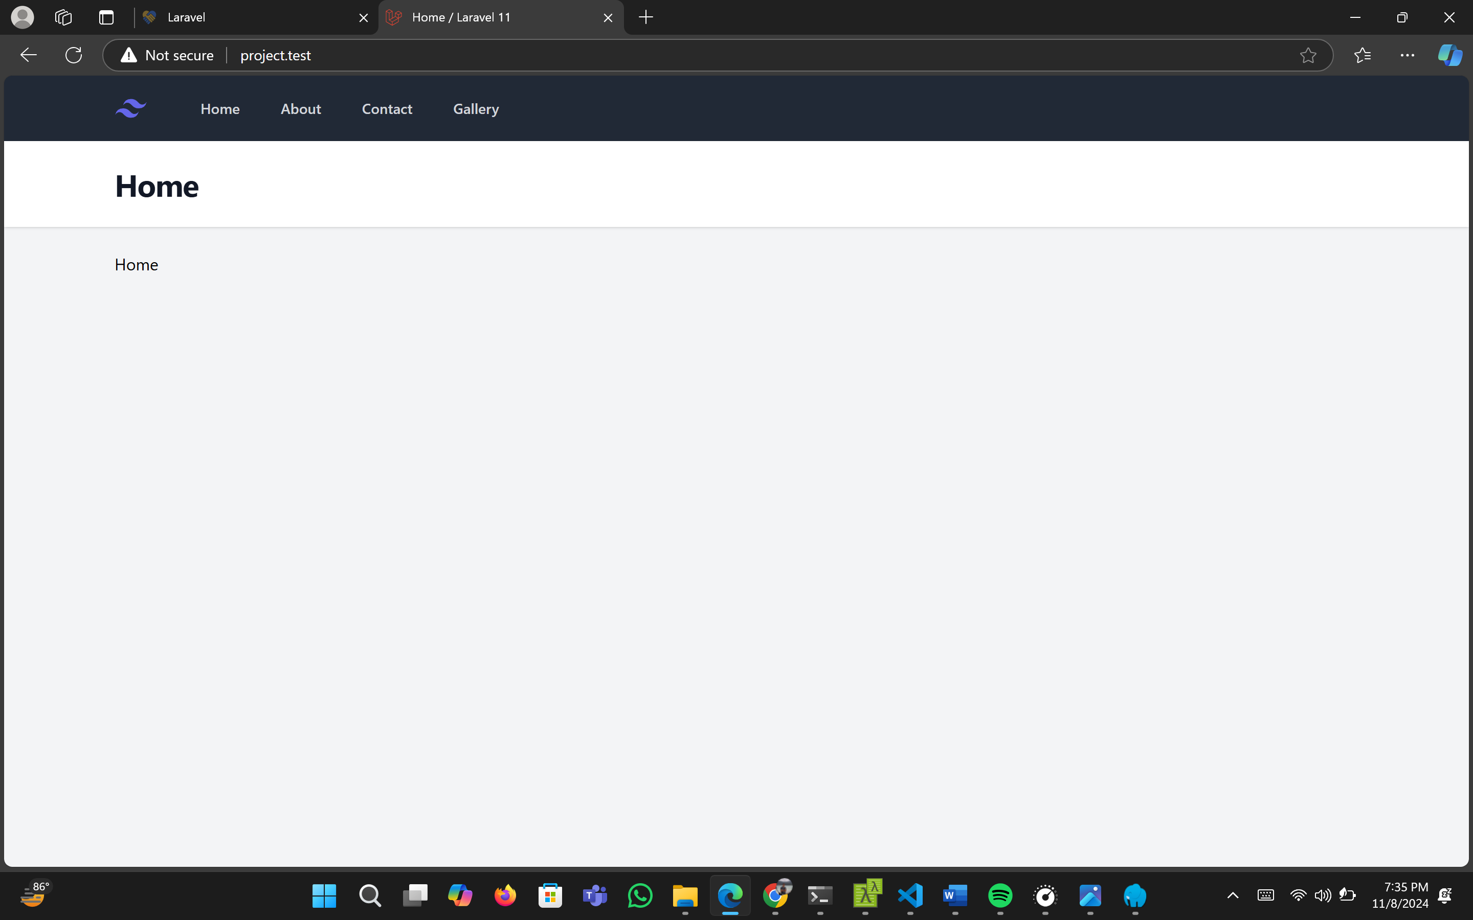

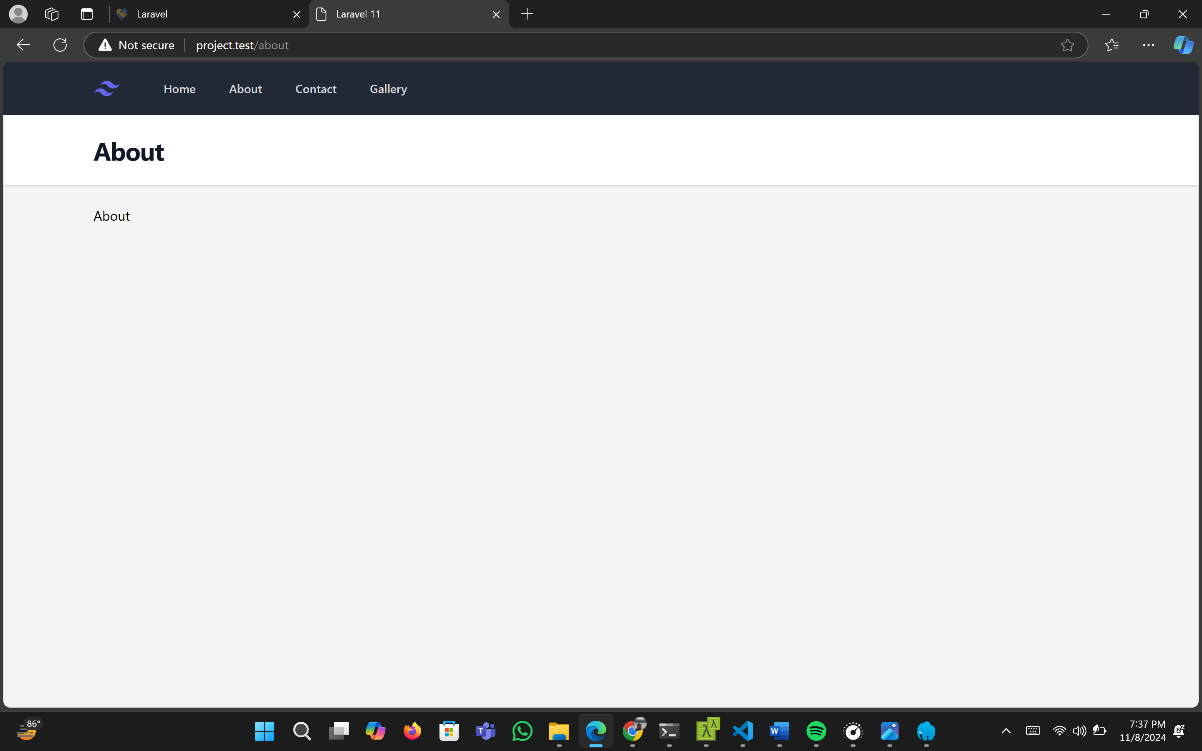

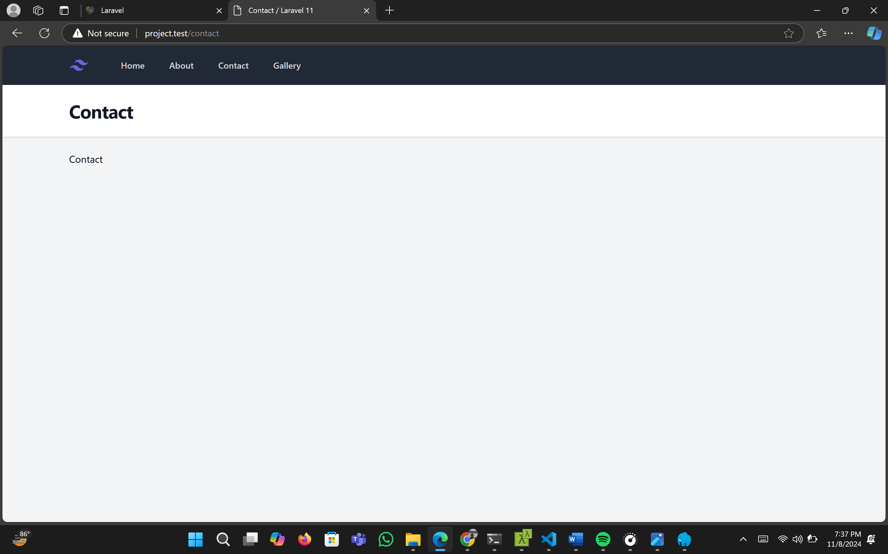

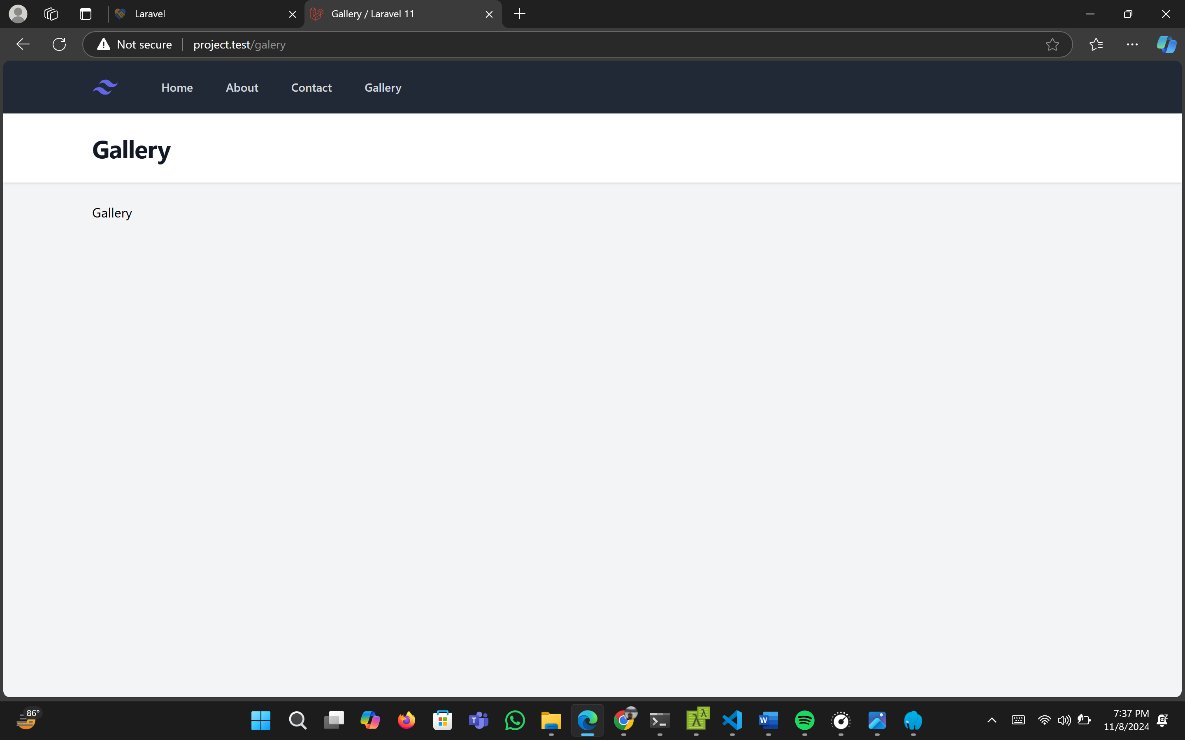

**IV. Screen Shoot Tampilan Video 04**

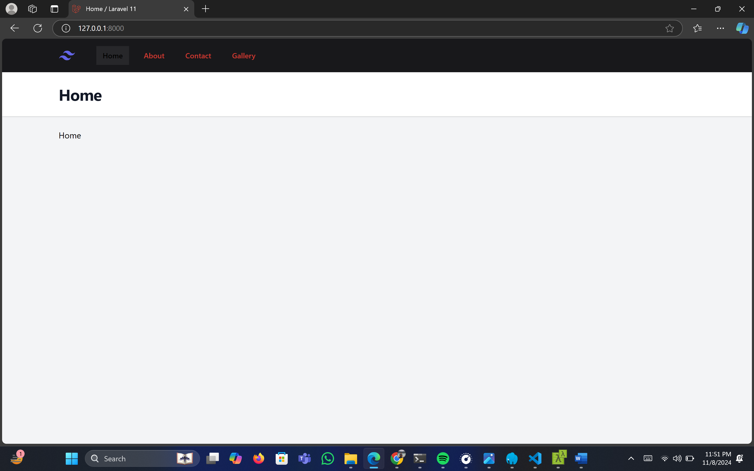

**V. Screen Shoot Tampilan Video 05**

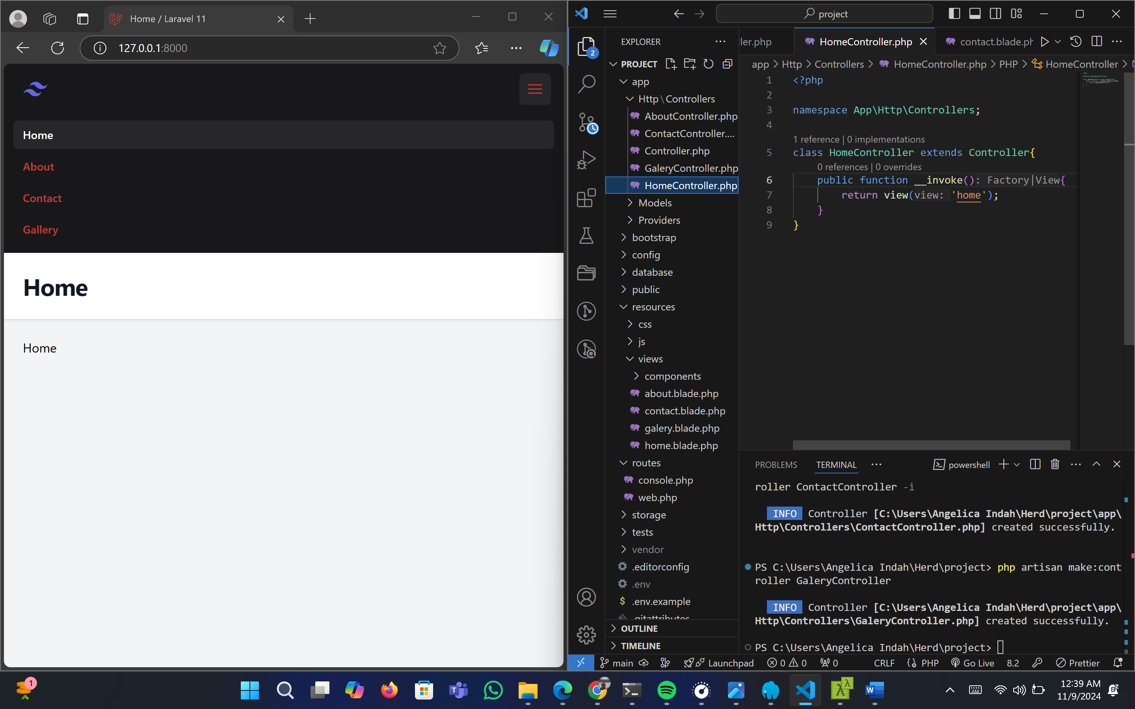

**VI. Screen Shoot Tampilan Video 06**

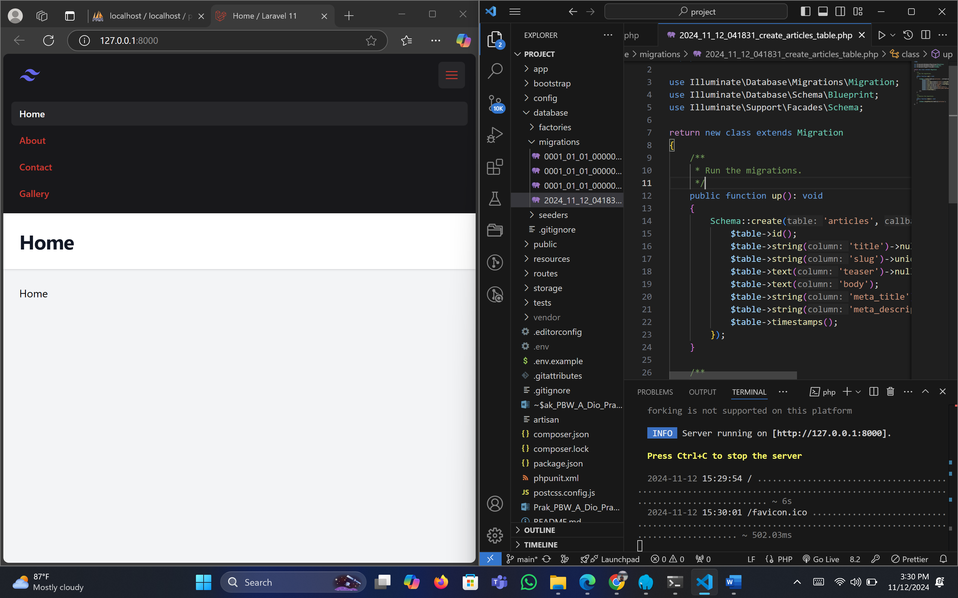

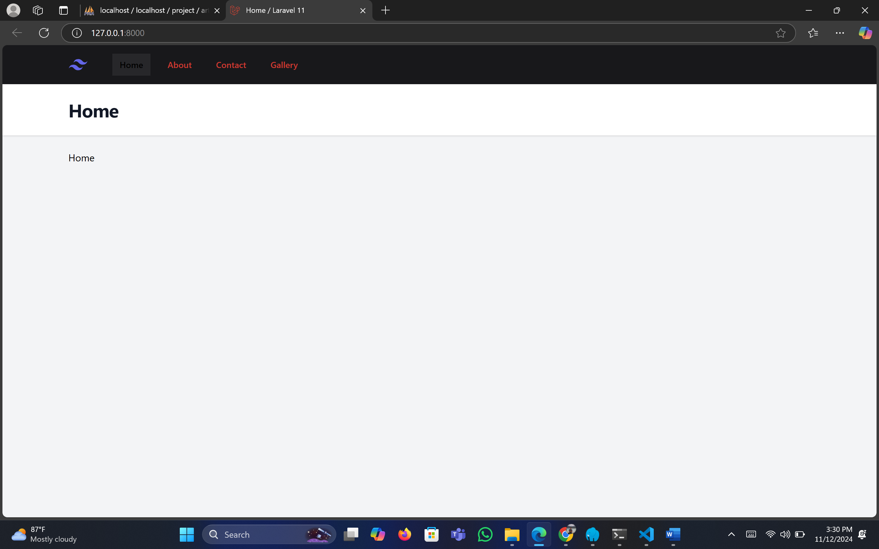

**VII. Screen Shoot Tampilan Video 07**

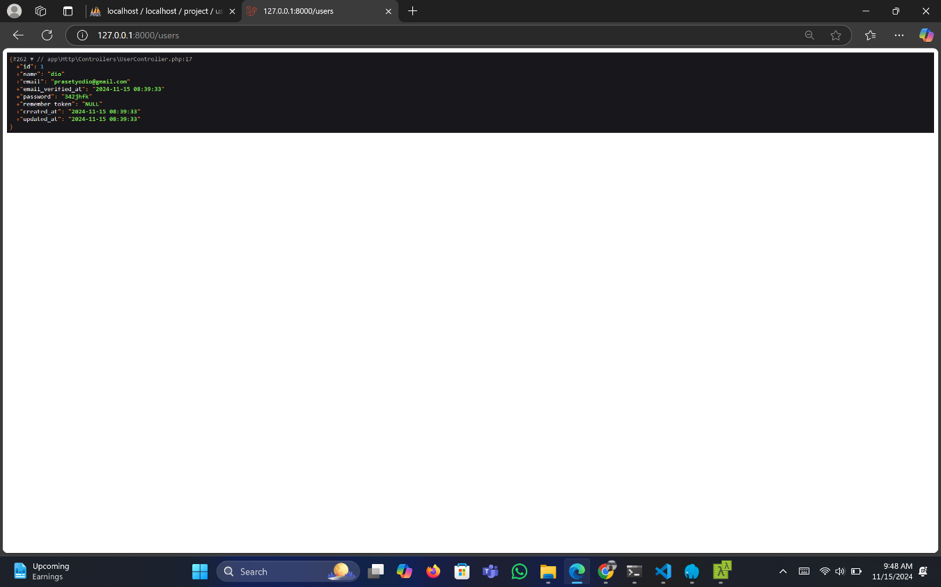

**VIII. Screen Shoot Tampilan Video 08**

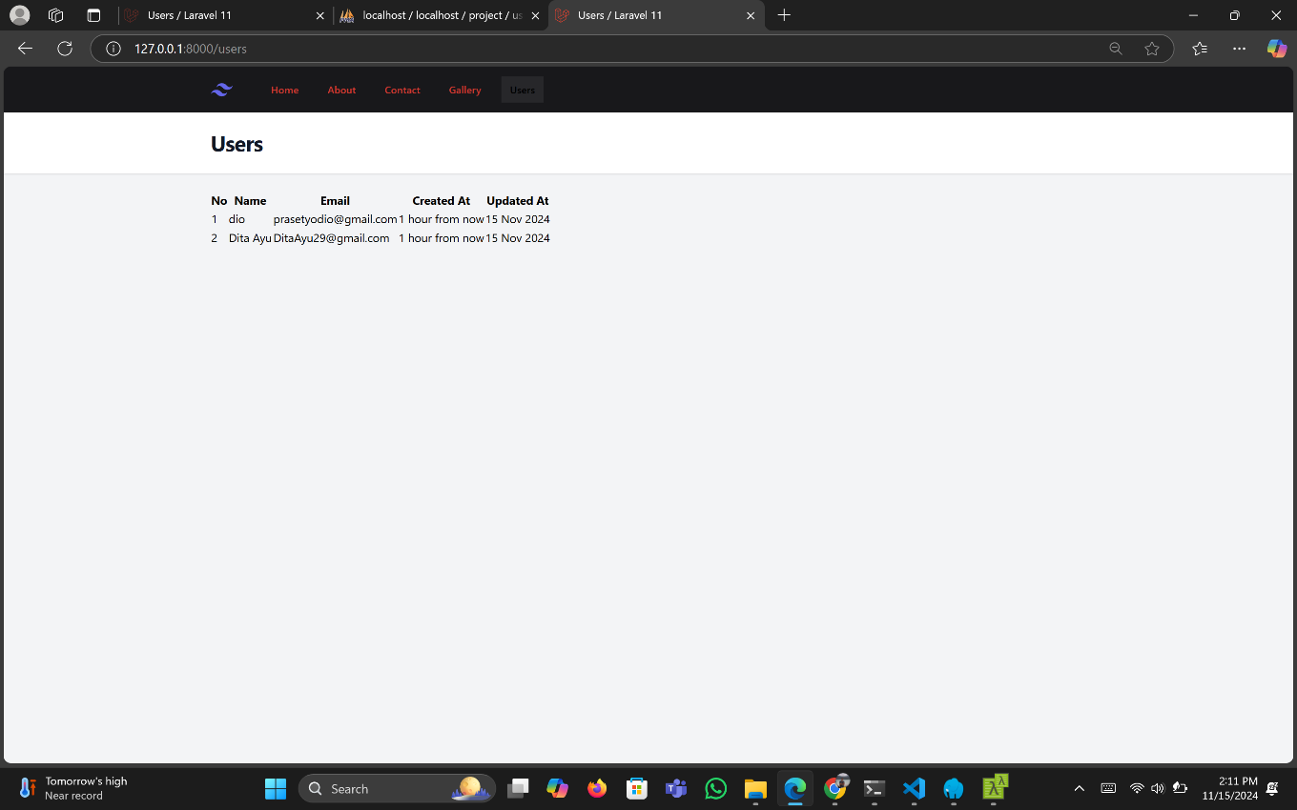

**IX. Screen Shoot Tampilan Video 09**

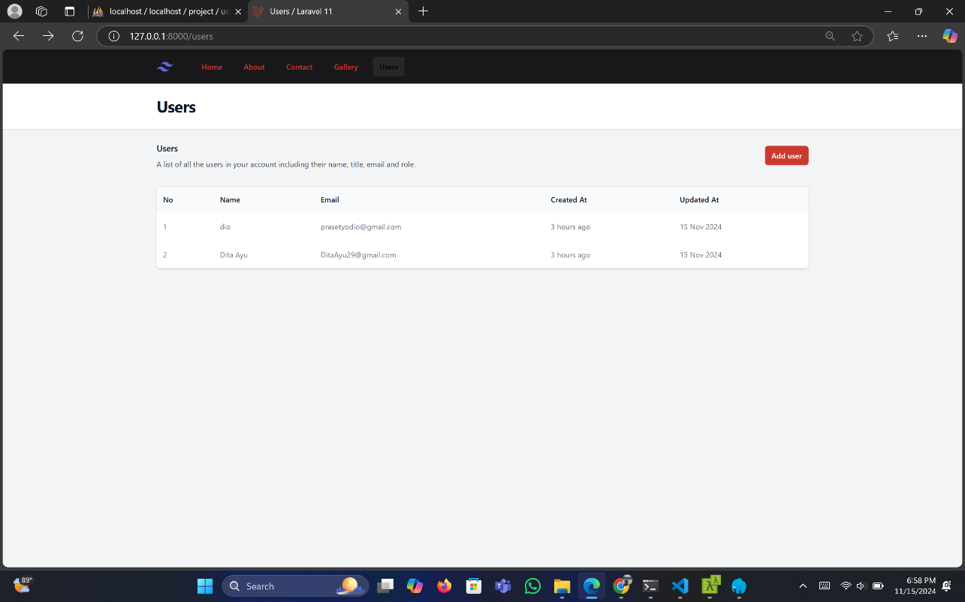

**X. Screen Shoot Tampilan Video 10**

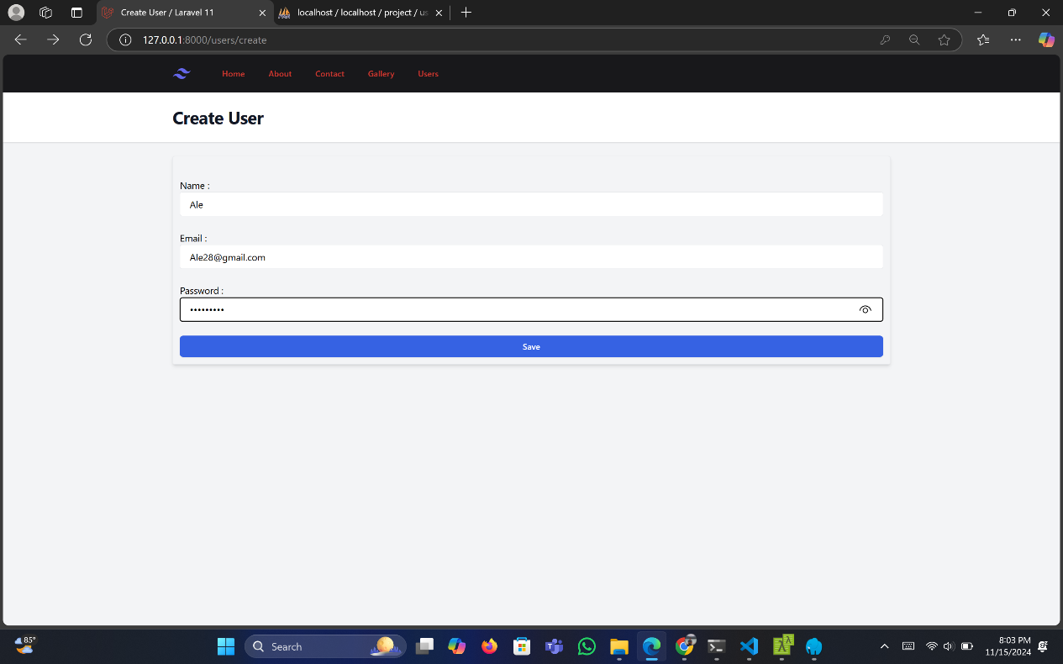

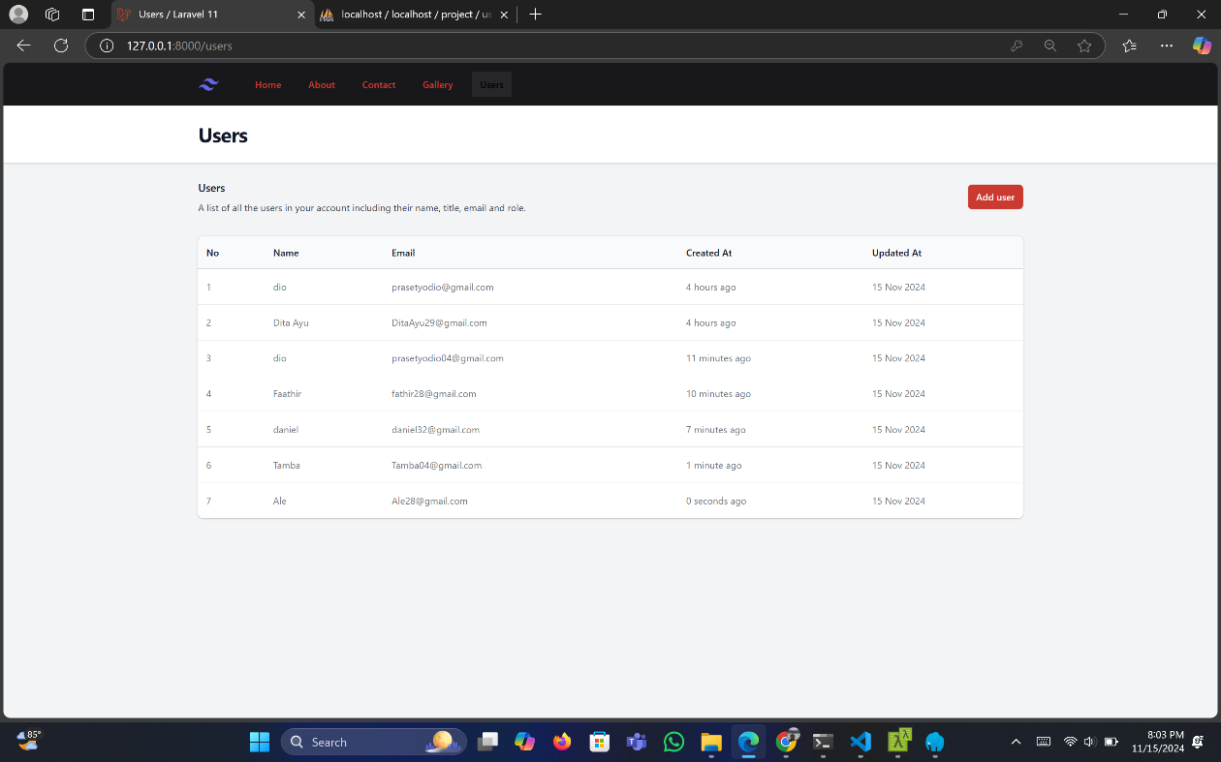

**XI. Screen Shoot Tampilan Video 11**

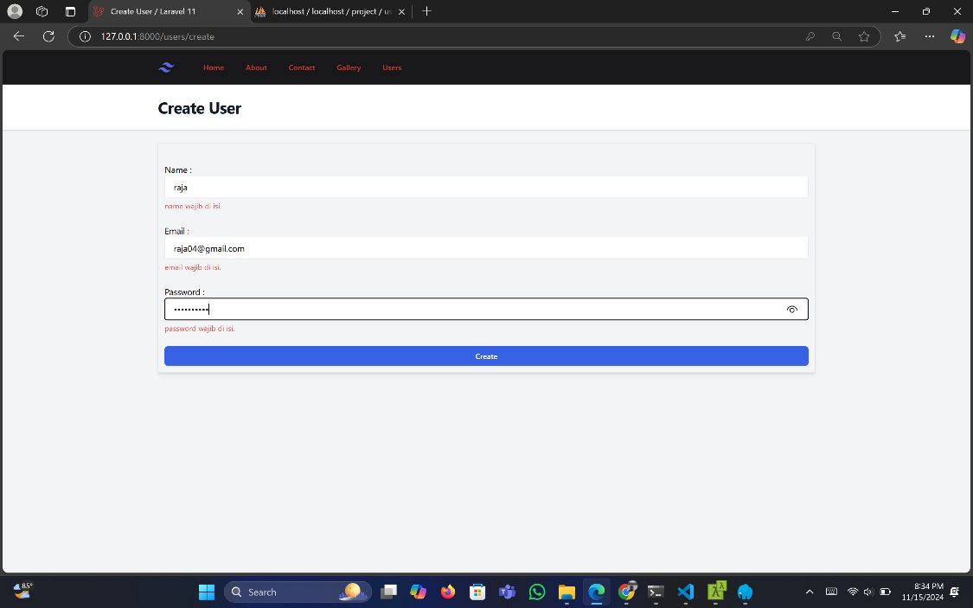

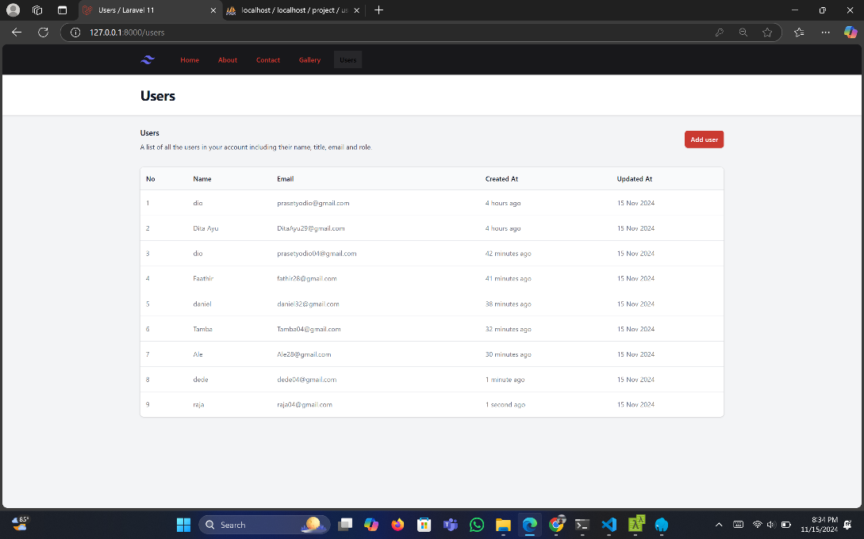

**XII. Screen Shoot Tampilan Video 12**

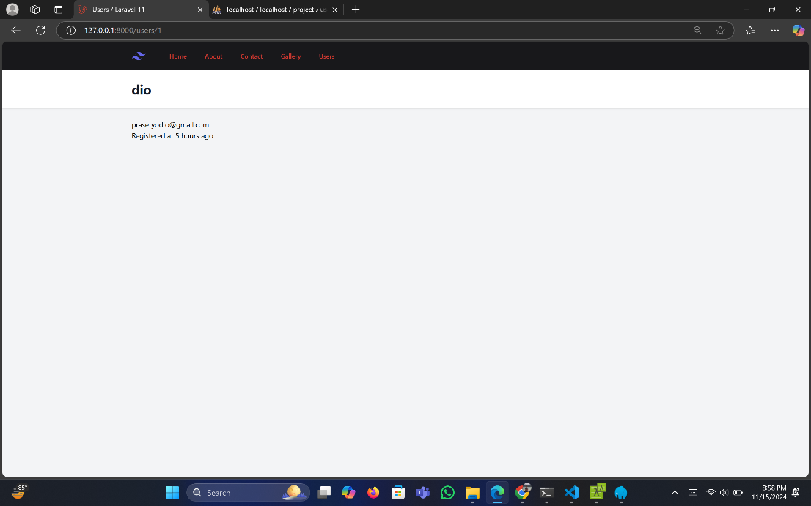

**XIII. Screen shoot tampilan video 13**

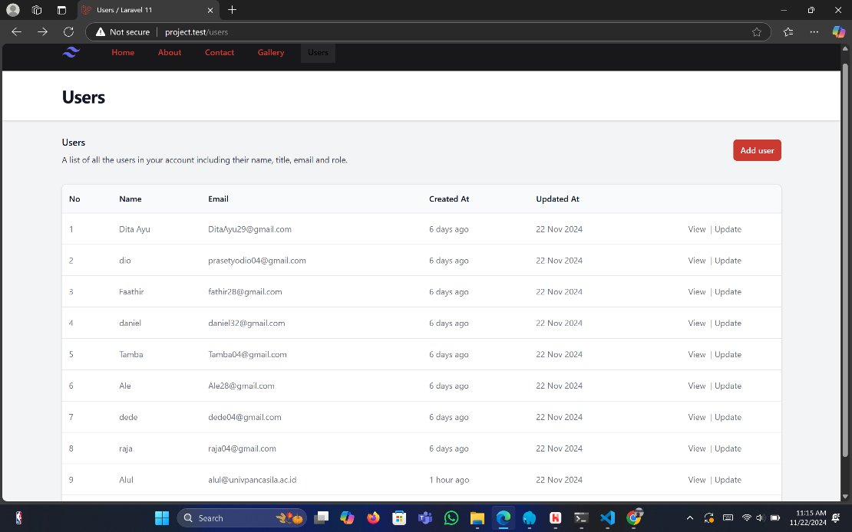

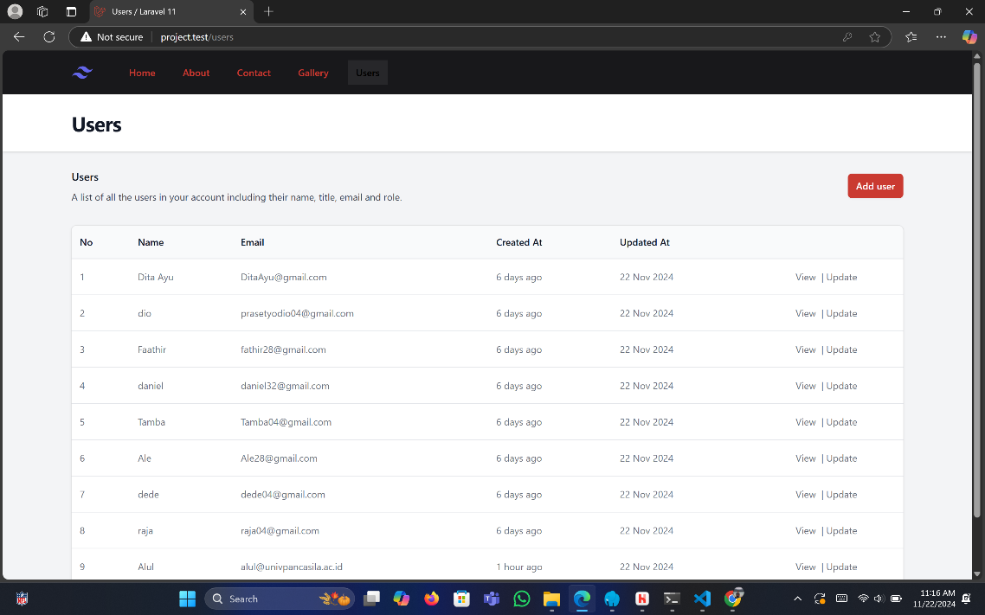

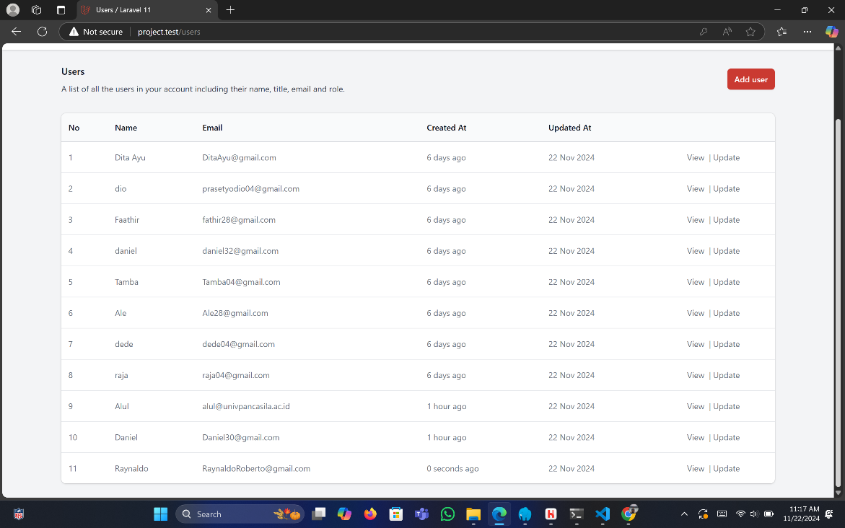

**XIV. Screen shoot tampilan video 14**

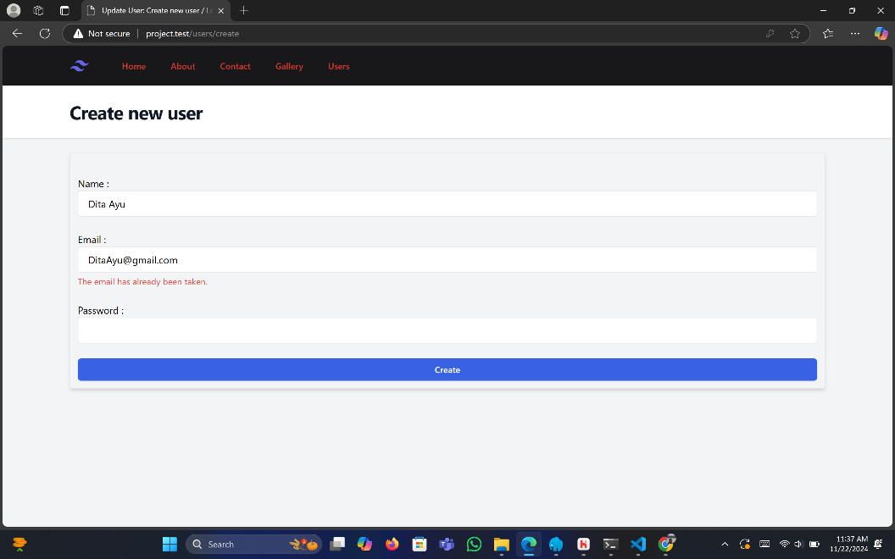

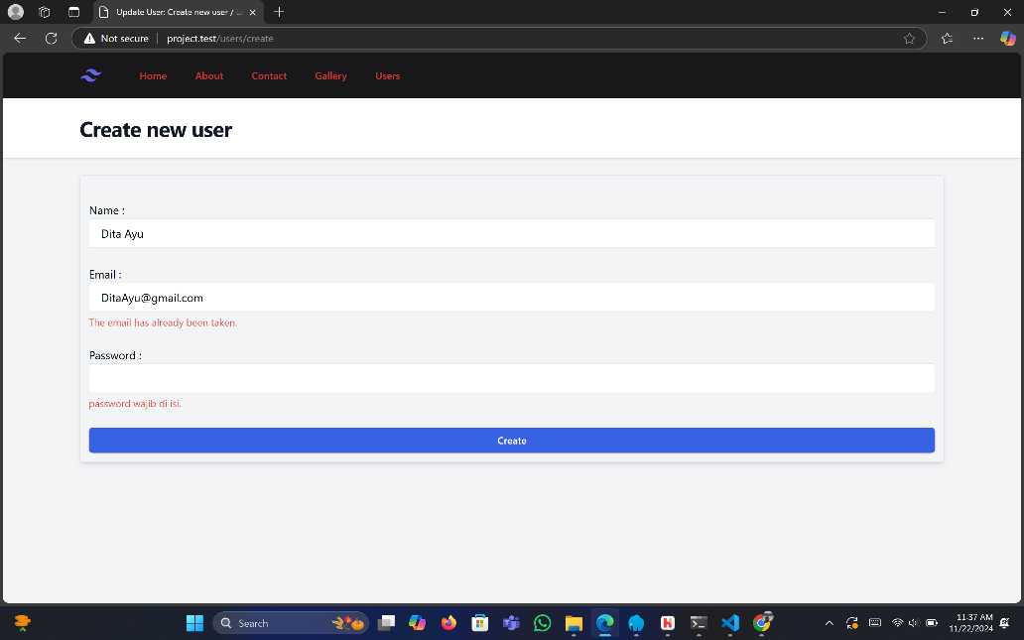

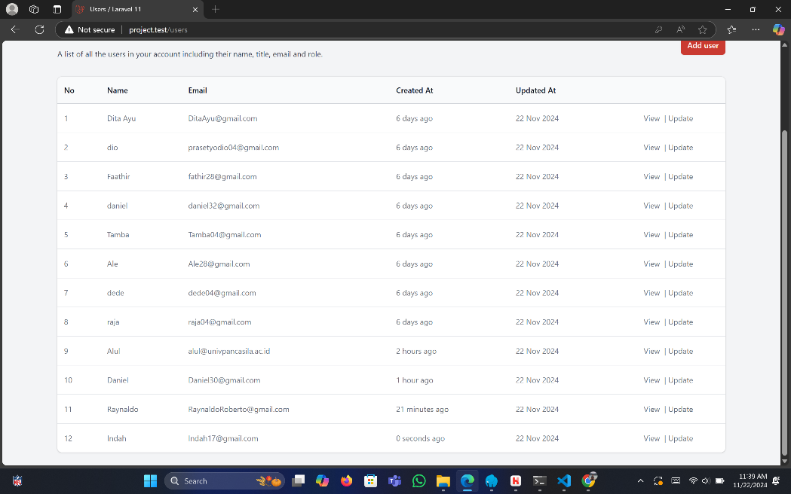

**XV. Screen shoot tampilan video 15**

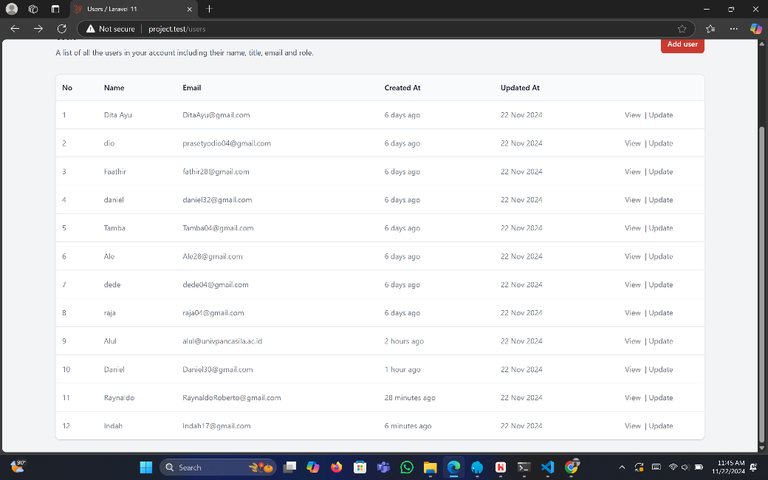

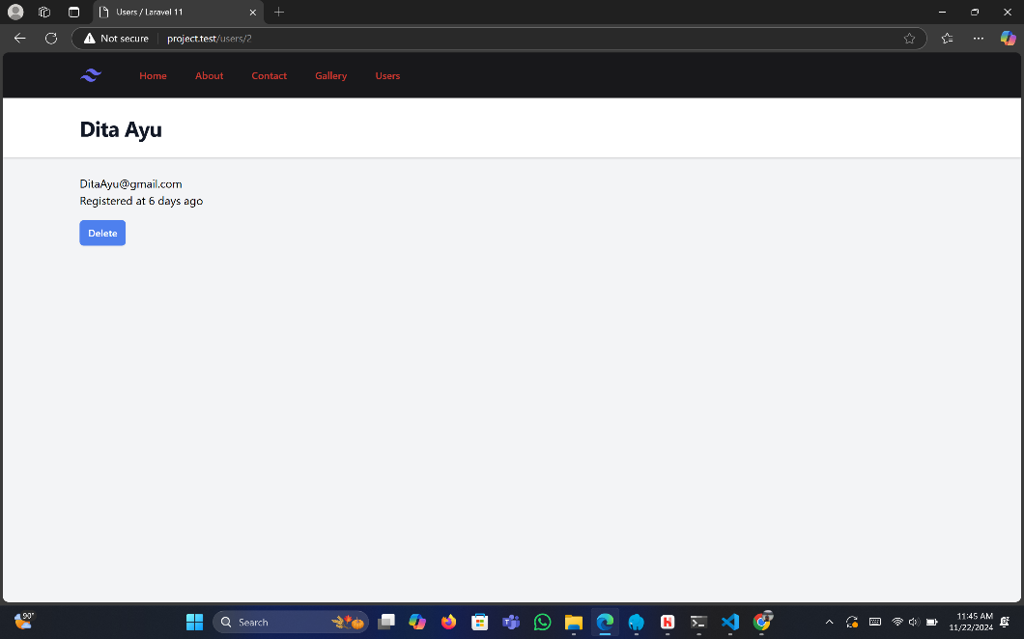

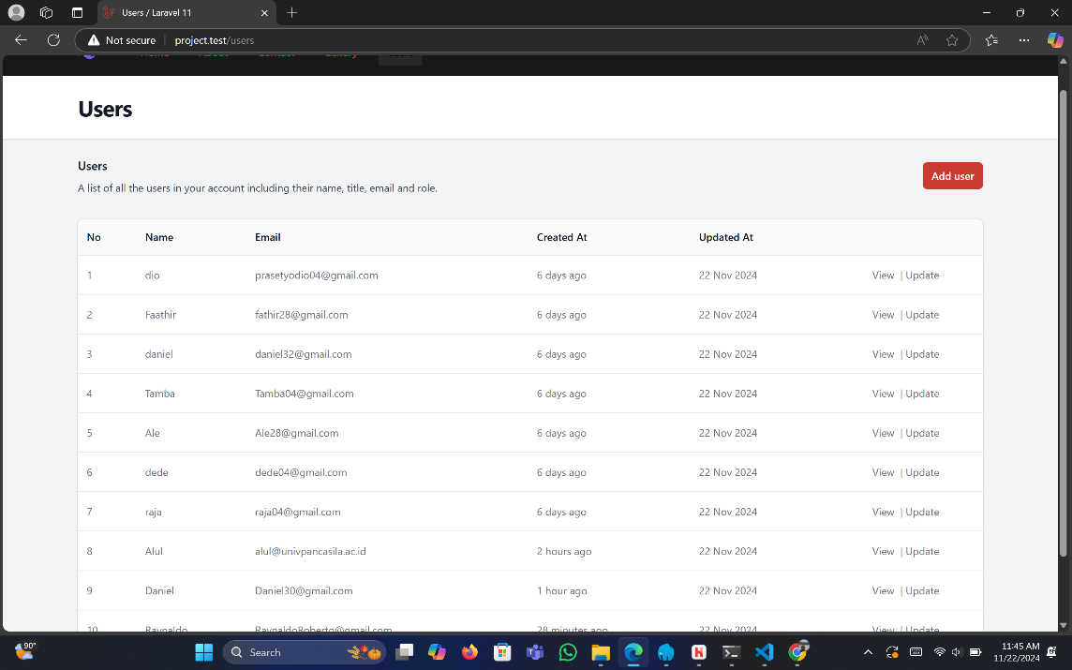

**XVI. Screen shoot tampilan video 16**

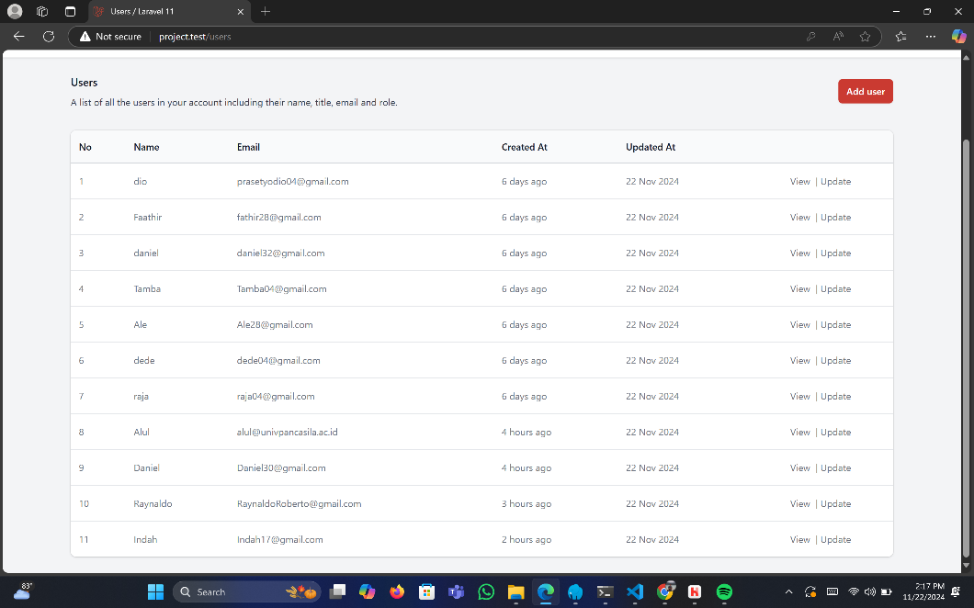

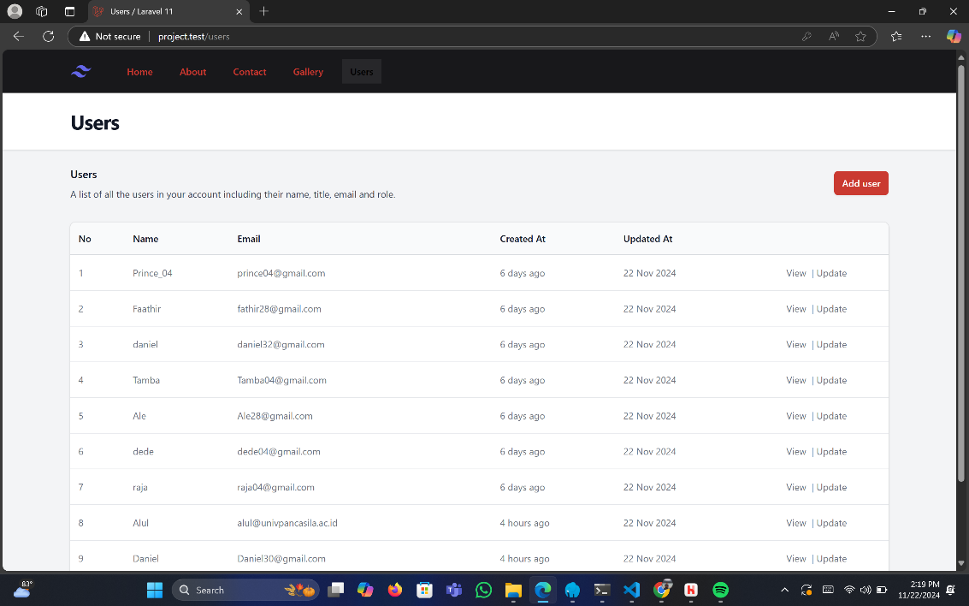

**XVII. Screen shoot tampilan video 17**

